UNITED STATES

SECURITIES AND EXCHANGE COMMISSION
Washington, D.C. 20549

FORM 6-K

REPORT OF FOREIGN PRIVATE ISSUER PURSUANT TO RULE 13a-16 OR 15d-16

UNDER THE SECURITIES EXCHANGE ACT OF 1934

FOR THE MONTH OF APRIL 2022

COMMISSION FILE NUMBER 001-41045

Mynaric AG

(Registrant’s name)

Dornierstraße 19

82205 Gilching

Germany

+49 (0) 8105 79990

(Address of principal executive offices)

Indicate by check mark whether the registrant files or will file annual reports under cover Form 20-F or Form 40-F: Form 20-F ☒ Form 40-F ☐

Indicate by check mark if the registrant is submitting the Form 6-K in paper as permitted by Regulation S-T Rule 101(b)(1): ☐

Indicate by check mark if the registrant is submitting the Form 6-K in paper as permitted by Regulation S-T Rule 101(b)(7): ☐

CONTENTS

Explanatory Note

On April 28, 2022, Mynaric AG (the “Company”) issued a letter providing a business update including preliminary numbers for the year ended December 31, 2021. The letter is furnished as Exhibit 99.1 to this Report on Form 6-K.

EXHIBIT INDEX

Exhibit |  | Description of Exhibit
99.1 |  | Letter issued by Mynaric AG on April 28, 2022

SIGNATURE

Pursuant to the requirements of the Securities Exchange Act of 1934, the registrant has duly caused this report to be signed on its behalf by the undersigned, thereunto duly authorized.

Mynaric AG
By | /s/ Stefan Berndt-von Bülow
 | Name: | Stefan Berndt-von Bülow
 | Title: | Chief Financial Officer
By | /s/ Sven Meyer-Brunswick
 | Name: Sven Meyer-Brunswick
 | Title: | Authorized Representative

Date: April 28, 2022

Exhibit 99.1
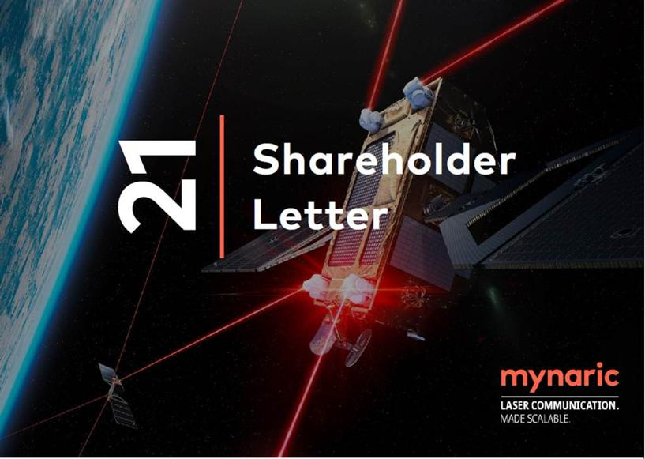

April 28, 2022

Table of Contents

Vision & Strategy | 2
Scale | 5
Customer Success Highlights | 9
Discussion of preliminary FY21 Results | 12
Outlook | 15
Summary | 16
Appendices | 17
Preliminary FY21 Results | 17
Analyst and Investor Day 2022 | 19
Investor Inquiries | 19
About Mynaric | 19
Forward-looking statements . | 20

Mynaric AG

Dornierstraße 19, 82205 Gilching, Germany

Managing Directors: Bulent Altan, Stefan Berndt- von Bülow, Joachim Horwath

www.mynaric.com

Fellow Shareholders,

We are writing to you today to update you on some key recent developments in our business activity - particularly how our vision is fueling our product strategy, our approach to scale, customer success, preliminary results FY21 and outlook.

FY21 was a year of milestone achievement with the company commencing serial production of optical communications terminals at our newly inaugurated production facility in Germany and multiple contracts with new and existing customers for unit shipments commencing in 2022 and beyond. We finished the year with the strongest order backlog in the company’s history. We believe this sets the stage for strong growth over the coming years as we capitalize on the growth of space-based optical communications networks.

Vision & Strategy

Our vision is to eliminate the barriers to connectivity and that is what we want to contribute to as a company. We strive to enable global connectivity by leading the industrial age of laser communication and making secure and high-speed optical communication available.

We see this as essential for two fundamental reasons that drive us forward:

- Ensuring a secure and unrestricted flow of information – crucial to protecting democracies globally and a main driver for many of our customers’ activities in the government market

- Closing the digital divide – for people and devices currently unconnected and a main driver for many of our commercial customers’ activities

This need for global communications networks is being driven out of both commercial as well as political necessity. Recent global developments such as Russia’s invasion of Ukraine should further accelerate the massive deployment of space capabilities on a global scale. Commercial broadband capabilities provided by satellite constellations impressively proved their worth with privately-owned SpaceX supporting Ukraine in this time of seriously compromised and partially destroyed existing communication links in Ukraine. The company quickly activated Starlink broadband services in Ukraine following Russia’s invasion and repeatedly shipped user equipment to the country while other geostationary satellite broadband services reportedly suffered service outages due to what looks like Russian electronic warfare aimed to sever communication links during the first hours of the invasion. The rapid service provisioning and resiliency of the system can be expected to fuel demand for broadband internet capabilities from mega -constellations and is a good demonstrator how strategic service demands from government customers fuel innovation by the commercial market.

Over the past years the number of active satellites in orbit increased significantly from around 950 in late 2010 to 1,900 satellites in late 2019 to around 4,800 satellites in late 2021 according to the Satellite Industry Association and the UCS Satellite Database. The number of communication constellation satellites increased by more than a factor of ten between late 2019 and late 2021 driven significantly by the start of satellite deployments as part of a number of commercial mega-constellations. Given these growth dynamics, we expect a continued rapid increase in active satellites in orbit. That growth of the last years pales in comparison to estimates for satellites in orbit by the end of this decade. Beyond Earth

FY21 Shareholder Letter
Mynaric (NASDAQ: MYNA)(FRA: M0Y)
www.mynaric.com | Page 2/21

Institute estimates that by 2030 there could be as many as 100,000 satellites in orbit. We believe the vast majority of these satellites will be part of communication constellations with each satellite in the constellation potentially requiring multiple optical communications terminals.

This growth is being driven by the need to provide always-on, ubiquitous communications capabilities across the globe and had significant impact on our company operations in 2022 as we saw more momentum build-up and customer traction with our products than ever before. We’ll dive deeper into customer success below.

Besides customer successes, in FY21, we achieved three other significant milestones that we believe best position us to capitalize on the tremendous growth opportunity ahead of us. These include:

1. Serial production in scale facility. In June, we opened the world’s first dedicated serial production facility located in Germany to produce optical communication terminals. With the opening of the new production facility, we continued to execute our strategy to build industrial capabilities required for the large volume deployment of laser communication products in proliferated aerospace networks.
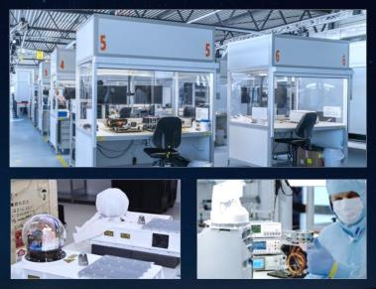

FY21 Shareholder Letter
Mynaric (NASDAQ: MYNA)(FRA: M0Y)
www.mynaric.com | Page 3/21

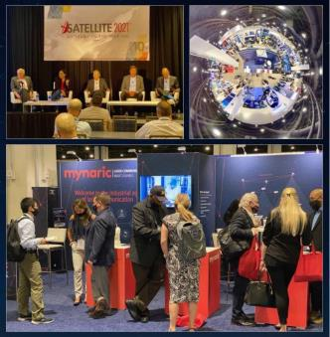

2. Expansion into the US. In February, we opened an office in Washington D.C. to provide closer proximity to key decision makers within the U.S. government and Department of Defense. We have hired a range of highly experienced US-based individuals from the aerospace industry and, in August, September and October, exhibited our products at various major conferences in the United States establishing a physical presence at the heart of our industry.
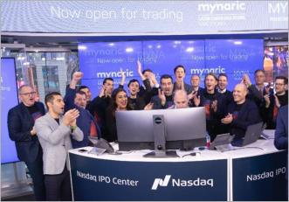

3. Nasdaq Initial Public Offering. In November, we listed 4.6 million American Depository Shares on the NASDAQ Global Select Market under the ticker symbol “MYNA” representing a strategic step towards US commercial and government customers and providing access to US-based investors and financial markets.

FY21 Shareholder Letter
Mynaric (NASDAQ: MYNA)(FRA: M0Y)
www.mynaric.com | Page 4/21

In 2021, we also introduced a new marketing slogan - Laser communication. Made scalable. - to promote Mynaric’s value proposition. And for a very strong reason: Our product strategy consists of four pillars that are designed from the ground up to facilitate the scalable deployment of laser communication capabilities for proliferated network architectures:

- Serial production - Strong focus on scalability - from product design over production to shipment - allows us to reach the production rates necessary to meet the demand for large quantities of optical communication terminals needed to build proliferated communication networks.

- Affordability - To offer best-in-class products at price points suitable for economic and large- scale deployments we strive to continuously reduce costs in product development and in our supply chain. Continued cost reduction efforts in product development and the supply chain result in significant cost savings allowing us to offer best-in-class products at price tags suitable for economic and large-scale deployments.

- Reliability and usability - Leveraging the benefits of laser communication technology should be as easy and as reliable as possible. That’s why we strive for industry-leading reliability and simplified integration of our products with out-of-the-box usability and flawless functionality.

- Standardization - We understand interoperability with third-party products and industry standards as key factors driving the adoption of laser communication systems and strive to make our products modularized to allow for maximum flexibility in their deployment and use.

Scale

These four strategic pillars are not mere lip-service: they are prominently reflected in existing capabilities and activities related to our scale capabilities:

- Serial Production: Our serial production facility near Munich, Germany, allows us to test and optimize production processes and quickly scale up production. Its size, layout and processes have been set up with a specific focus on scalable production which is adaptable to the dynamic developments expected from the laser communications market and the demand across distinct market verticals. Lean manufacturing principles drove the design of the 1,600m² facility with component part flow, workstations, final assembly, and testing capabilities optimized for efficiency and high throughput production. It functions as a sandbox to establish production capabilities and allows us to ramp up our production as dictated by market demand.
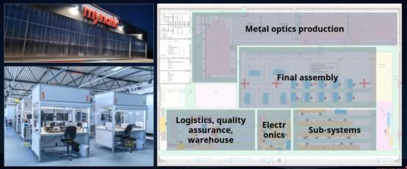

FY21 Shareholder Letter
Mynaric (NASDAQ: MYNA)(FRA: M0Y)
www.mynaric.com | Page 5/21

- Affordability: We insourced the production of high-fidelity metal optics, significantly improving the affordability of our products. Telescopes are a key component of optical communication terminals but those qualified for operation in space and featuring the required performance typically come at significant costs. We utilize telescopes made from metal rather than the typical but more expensive materials used for space products and insourced the processing. We have already insourced most production steps, including diamond-turning and magnetorheological finishing and we are expanding our capabilities, further allowing us to go from raw material to finished optical telescope entirely inhouse at significantly reduced cost.
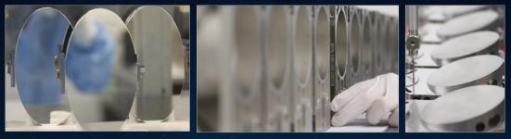

- Affordability: We operate an extensive parts qualification program to identify and use commercial electronics, reducing costs significantly compared to using more costly space-qualified electronics. Historically, faults induced by the radiation typical in space are a major hurdle for the utilization of standard, commercial electronics in space. We continuously conduct extensive test and qualification campaigns including total ionizing dose, proton and heavy ion testing to identify individual and batches of electronic components suitable for utilization in space, thereby reducing our costs for space-worthy electronics significantly.

FY21 Shareholder Letter
Mynaric (NASDAQ: MYNA)(FRA: M0Y)
www.mynaric.com | Page 6/21

- Affordability: We have already achieved significant material cost reductions with around 80% degradation of unit costs for the CONDOR Mk3 version compared to the initial Mk1 version and expect continued cost decreases once high-volume production of Mk3 commences.
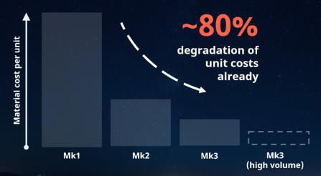

- Reliability: We conduct extensive testing of our products and components to eliminate faults early in the manufacturing process and make our products’ utilization as reliable as possible. Exemplarily, we operate vibration tables to stress-test our products’ resilience in different vibration environments and a moving hexapod test platform to emulate satellite or aircraft movements. Multiple thermal chambers are used to simulate varying temperatures typically encountered by our products when in operation and we utilize a thermal vacuum chamber to test the combined effects of varying temperatures with different pressures.
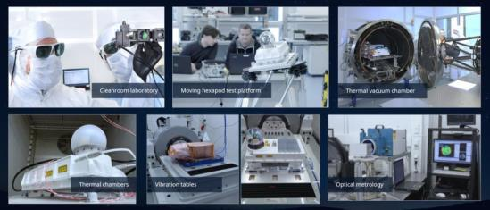

FY21 Shareholder Letter
Mynaric (NASDAQ: MYNA)(FRA: M0Y)
www.mynaric.com | Page 7/21

- Simplicity: We continuously conduct outdoor and flight campaigns to optimize and gain insights into the usability of our products in typical real-world scenarios. We have established a remote- controlled outdoor testbed and routinely operate ground-to-ground links subject to the influence of atmospheric effects and we regularly conduct flight campaigns with different airframes such as ultra-lights and high-altitude long-endurance aircraft. The breadth of test campaigns with different environmental conditions and link situations provides us with invaluable insights to further improve our products and provide best-in-class customer support.
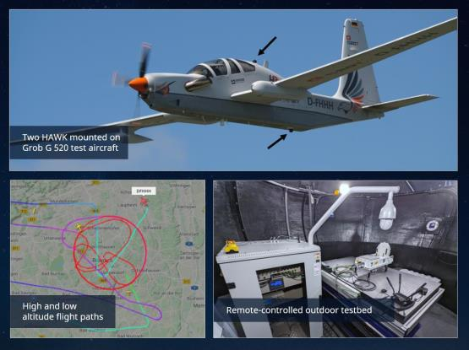

- Standardization: Our interoperability labs in Germany and the United States allow us to trailblaze standardization efforts in the industry. These interoperability labs are equipped with link testbeds that allow data transmission testing over different (simulated) link distances while replicating various environmental effects typically encountered in air and space. Our labs allow for testing of various parameters including motion, micro-vibration, acquisition, and point-ahead and associated effects thereby creating an environment to verify interoperability and allow cross- testing with other vendors.
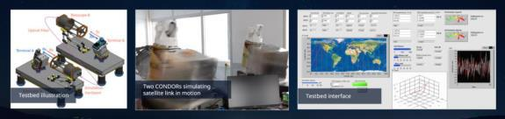

FY21 Shareholder Letter
Mynaric (NASDAQ: MYNA)(FRA: M0Y)
www.mynaric.com | Page 8/21

Customer Success Highlights

As we look to 2022 and the subsequent years, we see substantial opportunities in both the commercial and government markets. Based on our year-end backlog and new opportunity pipeline, the space domain represents the largest revenue opportunity with programs spanning both commercial and government programs with upcoming volume deliveries.
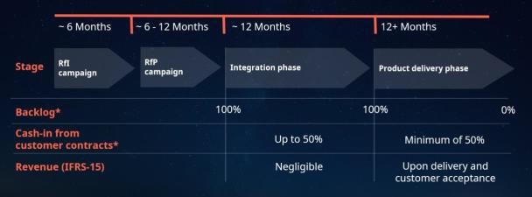

Figure 1: Typical program lifecycle and milestones

We continuously nurture our contacts in the industry and utilize multiple engagement channels to gather market intelligence about upcoming programs. After lead targeting and qualification, the first in-depth customer engagement often comes in the form of a customer-initiated Request for Information (RfI) campaign. This is especially prevalent for larger space programs in the government market. This phase typically last up to 6 months. During this phase our business development and sales team provide the customer with preliminary information about our products’ suitability in the context of the specific program at hand. This phase is typically followed by a Request for Proposal (RfP) campaign that typically includes further refinements of specific program requirements and explanations and generally results in an actual firm bid. The bid is composed of unit volumes, prices, delivery times and payment milestones among other aspects and is the basis for the customer’s product selection.

Once a customer opportunity is won, and respective contracts and agreements are signed optical communications terminal backlog represents the quantity of all open optical communications terminal deliverables in the context of signed customer programs at the end of a reporting period. Optical communications terminals are in in this context defined as the individual devices responsible for pointing the laser beam and capable of establishing a singular optical link each. The optical communications terminal backlog particularly includes:

- Optical communications terminal deliverables related to customer purchase orders; and

- Optical communications terminal deliverables in the context of other signed agreements.

Hence, backlog is calculated as the order backlog at the beginning of a reporting period plus the order intake within the reporting period minus terminal deliveries and recognized as revenue within the reporting period and as adjusted for canceled orders, changes in scope and adjustments. If there are multiple options for deliveries or services under a particular purchase or binding agreement, backlog

FY21 Shareholder Letter
Mynaric (NASDAQ: MYNA)(FRA: M0Y)
www.mynaric.com | Page 9/21

only takes into account the most likely contract option based on management assessment and customer discussions.

After contract signature we typically move to the integration phase of a customer program. During this phase our team engages closely with the customer to prepare frictionless integration of our products onto the customer’s platform along a predefined milestone plan. This stage of the engagement may last up to a year. Shipments of small quantities of product for testing and demonstration typically occur during this phase as the insights and documentation created along these milestones are critical for the program’s success when volume shipments commence.

Cash-in from customer contracts includes payments from customers under purchase orders and other signed agreements, including accrued payment milestones under customer programs. We often accrue meaningful payment milestones already during the integration phase that precedes customer deliveries, and we believe cash received from customer contracts are a meaningful indicator of upcoming revenues to be recognized during the product delivery phase of customer programs.

Finally, once integration work is mostly concluded, we move to the product delivery phase that may stretch from as little as a few months to years depending on the scale of the customer program. It’s typically a few months from commencement of product shipments until the first customer platforms equipped with our products are launched to space or take off from the runway and start their operational utilization.

During this phase we generally start to accrue revenue which is typically recognized once a product or service has been received by the customer and its delivery is completed. Revenue may also accrue through individual and independent milestones of customized customer programs that may already happen during the preceding integration phase. Recognized revenue due to shipped optical communications terminals will results in the respective reduction in the backlog.
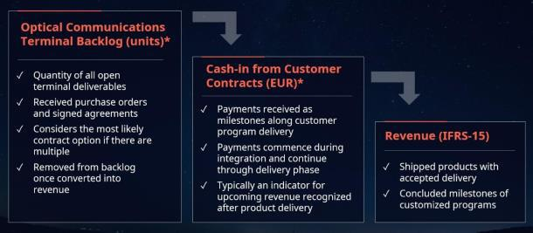

Figure 2: Key Business Metrics Translation into Recognized Revenue

FY21 Shareholder Letter
Mynaric (NASDAQ: MYNA)(FRA: M0Y)
www.mynaric.com | Page 10/21

In FY21, we achieved a series of important customer milestones falling on different phases of this typical customer program lifecycle:

In May, we achieved the industry’s first over-the-air transmission using an optical communications terminal communicating with an independently built testbed both of which are compliant with the Space Development Agency’s (SDA) optical inter-satellite link standard. The demonstration was composed of a set of optical and electronic tests utilizing Mynaric’s CONDOR product. The successful demonstration is confirmation that CONDOR is downward compliant with the Space Development Agency’s optical communications terminal standard, thus ensuring baseline compatibility with products of other vendors implementing the same standard. The demonstration was conducted for a customer who is under contract with the SDA.

In August, Mynaric and SpaceLink agreed on the framework of a partnership to expand our laser communication product portfolio for use in SpaceLink’s data relay network. The partnership will help drive forward the SpaceLink satellite relay service, which provides secure, continuous, high-capacity communications between low Earth orbit spacecraft and the ground. Mynaric’s product portfolio was a natural choice as it meets SpaceLink’s programmatic requirements, provides high performance, and is fully compliant with the optical communications terminal standard driven by the SDA. We were selected as a supplier to support SpaceLink’s mission given its industrialized approach towards the production of advanced laser communication products.

In November, we were disclosed as Capella Space’s supplier for optical inter-satellite links. Capella Space is the first commercial Synthetic Aperture Radar company to demonstrate compatibility with the U.S. SDA’s National Defense Space Architecture, a large-scale satellite constellation providing a range of capabilities to U.S. Department of Defense. We will be delivering our next generation optical communications terminal, CONDOR Mk3, to Capella Space to ensure this compatibility.

In November, Mynaric signed a multi-year, strategic agreement with Northrop Grumman that identifies the company as a strategic supplier for laser communications in the space domain. The agreement provides Northrop Grumman assured and preferred access to Mynaric products and services. It also foresees that ourselves and Northrop Grumman will jointly develop and offer laser communication solutions tailored to the unique needs of specific U.S. government space programs. We will exclusively develop and sell custom products to Northrop Grumman for this specific market segment. Separately, Northrop Grumman issued a purchase order for a set of CONDOR Mk3 terminals to kick-start the relationship.

In December, we were selected to provide the architectural design of a next-generation optical communications terminal as part of the phase 0 of the Space Based Adaptive Communications Node (Space-BACN) program of the Defense Advanced Research Projects Agency (DARPA). DARPA’s Space-BACN program envisions an optical communications terminal that could be reconfigured to work with most of today’s optical intersatellite link standards allowing seamless communication among government and private-sector proprietary satellites and satellite constellations. The selection for the phase 0 of the program is yet another win for Mynaric in the US government market; a driving force for the deployment of space-based, laser communication capabilities.

FY21 Shareholder Letter
Mynaric (NASDAQ: MYNA)(FRA: M0Y)
www.mynaric.com | Page 11/21

Subsequent to year-end 2021, in January 2022, Mynaric was awarded a contract by the European Space Agency (ESA) to analyze, design, build and test on a laboratory model an end-to-end optical communication system that can achieve data transmission speeds of up to 1 Terabit per second (Tbps).

In March 2022, we entered into a definitive agreement with Northrop Grumman for the delivery of optical communication terminals as part of the framework of a U.S. government space program led by the SDA. The contract, with an initial value of USD 36 million, has performance-based payment milestones throughout 2022, 2023 and 2024 and product deliveries mostly in 2023 and 2024.

Discussion of preliminary FY21 Results1

For FY21, revenue is expected to increase by more than 240% year over year to mEUR 2.4 (FY20: mEUR 0.7). Cash-in from customer

contracts is expected to increase by more than 100% year over year to mEUR 3.9 (FY20: mEUR 1.9).
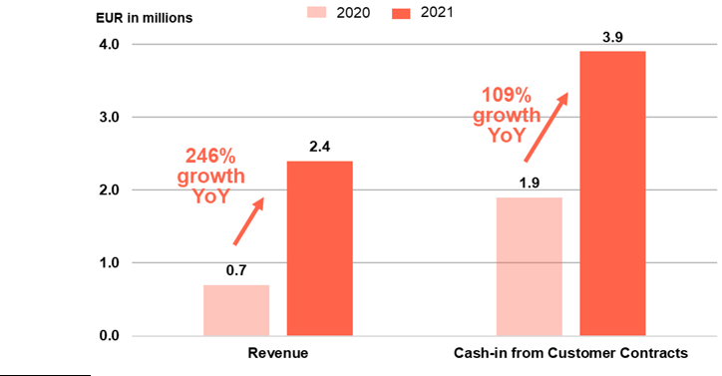

- Mynaric has not yet completed preparation of its financial statements for the year ended December 31, 2021. The information presented herein is preliminary in nature and is subject to change, including as a result of any normal adjustments resulting from completion of procedures in relation to the financial statements for the financial year 2021.

FY21 Shareholder Letter
Mynaric (NASDAQ: MYNA)(FRA: M0Y)
www.mynaric.com | Page 12/21

Mynaric’s financial performance in FY21 was heavily influenced by a strong focus on product development and investment in scale capacity. We invested in specialized equipment and machinery for increased production capacity, exemplarily our vertically integrated optics production, as a result of which we expect assets in property, plant and equipment to increase to mEUR 16.8 (FY20: mEUR 10.1). We also expect inventories to increase to mEUR 8.5 (FY20: mEUR 5.2) in order to establish production in high quantities and increase our ability to deliver products despite the tense situation with international supply chains. We expect our cash and cash equivalents to be higher than in FY20 with cash and cash equivalents in FY21 expected to amount to mEUR 48.1 (FY20: mEUR 43.2). This balance includes the positive contribution from our NASDAQ IPO we completed in November 2021. We are now dual listed in Germany and in the US. We welcomed a number of new shareholders with the IPO. This positive contribution is expected to be nearly offset by the higher operating loss and investments in property, plant and equipment as well as inventory to support future growth.
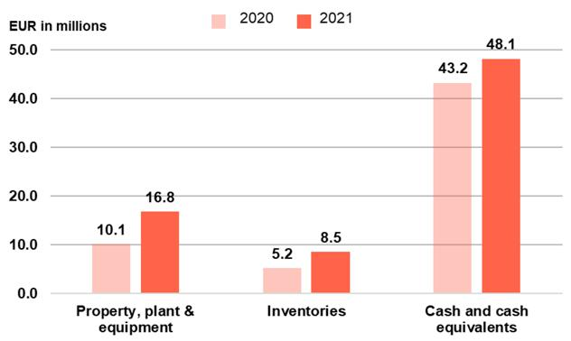

FY21 Shareholder Letter
Mynaric (NASDAQ: MYNA)(FRA: M0Y)
www.mynaric.com | Page 13/21

FY21’s strong focus on the development of our products and building terminals is also reflected by increased cost of materials which are expected to amount to mEUR 10.7 (FY20: mEUR 6.2).2 Continued hiring of skilled employees is expected to result in higher personnel expenses of mEUR 23.4 (FY20: mEUR 16.8).3 The operating loss, mostly a result of continued investments to position the company for future growth in the business, is expected to increase to mEUR -42.3 (FY210: mEUR -19.3).

- Cost of materials are expected to amount to mEUR 10.7 of which mEUR 2.0 are capitalized costs in FY21 (FY20: mEUR 6.2 of which mEUR 4.1 are capitalized costs).
3 Personnel costs are expected to amount to mEUR 23.4 of which mEUR 1.9 are capitalized costs in FY21 (FY20: mEUR 16.8 of which mEUR 3.9 are capitalized costs).

FY21 Shareholder Letter
Mynaric (NASDAQ: MYNA)(FRA: M0Y)
www.mynaric.com | Page 14/21

Outlook

As the value and necessity of capabilities provided from space for the benefit on Earth continues to increase, it is ever more evident that we are on the front end of a substantial market opportunity. We continue to remain in ramp growth mode to fully seize this market opportunity in the short-term and, importantly, position the company as the market continues to experience significant long-term growth.

Starting in 2022, we are introducing two key business metrics that we believe align with this opportunity and best represent the company’s progress on our long-term vision and mission:

- Optical Communications Terminal Backlog, and

- Cash-in from Customer Contracts


 | FY20a | FY21a | FY22e
Optical
Communications | 3 | 40 | 211 YTD
Terminal Backlog | 3 | 40 | 211 YTD
(units)
Cash-in from | mEUR 1.9 | mEUR 3.9 | More than mEUR 20
Customer Contracts | mEUR 1.9 | mEUR 3.9 | More than mEUR 20
Table 1: Company guidance for FY22

Our optical communications terminal backlog significantly grew year-over-year from 3 units in backlog at end of FY20a to 40 units at end of FY21a – a growth of more than 10x. 2022 is set to become yet another record-breaking year with more than a 5x backlog increase already in the first four months of the year to 211 units year to date. Cash received from customer contracts developed equally satisfactory with a growth from mEUR 1.9 in 2020 to mEUR 3.9 in 2021 growing more than 100% year-over-year. Cash received from customer contracts is expected to exceed EUR 20 million in FY22e based on our current optical communications terminal backlog, expected shipments to customers and our sales pipeline.

FY21 Shareholder Letter
Mynaric (NASDAQ: MYNA)(FRA: M0Y)
www.mynaric.com | Page 15/21

Summary

Our industry experiences more growth and momentum than ever before and our milestones achieved in FY21 significantly improved our positioning to seize the multi-decade opportunity ahead of us. When we talk about growth and momentum, we’re not merely speaking in terms of double-digit or multiple double-digit percentage growth but rather, we’re talking about growth in multiples year over year. Our optical communications terminal backlog is an example of this. Mynaric is at its core centered around the scalability that enables us to leverage this momentum to the fullest. We are on track to provide our customers with unprecedented communication capabilities enabling them to establish large, proliferated networks and making our vision to eliminate the boundaries of connectivity a reality.

We sincerely thank our employees, customers, suppliers and shareholders for their continued support as we pursue the industrial age of laser communication.

Sincerely,


Bulent Altan | Stefan Berndt-von Bülow | Joachim Horwath
CEO | CFO | CTO & Founder
FY21 Shareholder Letter
Mynaric (NASDAQ: MYNA)(FRA: M0Y)
www.mynaric.com |  | Page 16/21

Appendices

Preliminary FY21 Results⁴

Consolidated statements of profit or loss and other comprehensive income or loss for the year ended December 31, 2021, 2020 and 2019.

in € thousand | 2021 | 2020 | 2019
Revenue | 2,355 | 679 | 114
Other operating income | 435 | 294 | 252
Cost of materials | -10,676 | -6,221 | -2,790
of which capitalized costs | 1,995 | 4,073 | 2,089
Personnel costs | -23,364 | -16,834 | -9,407
of which capitalized costs | 1,906 | 3,921 | 2,551
Depreciation, amortisation and impairment of other intangible assets and property, plant and equipment | -4,518 | -1,843 | -1,117
of which capitalized costs | 287 | 802 | 494
Other operating costs | -11,831 | -5,345 | -2,813
of which capitalized costs | 427 | 579 | 277
Change in inventories of finished goods and work in progress | 717 | 637 | 272
Own work capitalized | 4,615 | 9,375 | 5,411
Operating profit/loss | -42,266 | -19,257 | -10,078
Interest and similar income | 0 | 18 | 73
Interest and similar expenses | -2,148 | 0 | 0
Net foreign exchange gain / (loss) | 826 | -531 | 109
Net finance costs | -1,322 | -513 | 182
Profit/loss before tax | -43,588 | -19,770 | -9,896
Income tax expense | -1,785 | 0 | 0
Consolidated net profit/loss | -45,373 | -19,770 | -9,896
Other comprehensive income/loss
Items which may be subsequently reclassified to profit and loss
Foreign operations – foreign currency translation differences | -500 | 367 | -43
Total | -500 | 367 | -43

- Mynaric has not yet completed preparation of its financial statements for the year ended December 31, 2021. The information presented herein is preliminary in nature and is subject to change, including as a result of any normal adjustments resulting from completion of procedures in relation to the financial statements for the financial year 2021. There can be no assurance that the final results for these periods will not differ from these preliminary results, and any such differences could be material. Financial results for the financial year 2021 will be included in Annual Report on Form 20-F to be filed with the Securities Exchange Commission.

FY21 Shareholder Letter
Mynaric (NASDAQ: MYNA)(FRA: M0Y)
www.mynaric.com | Page 17/21

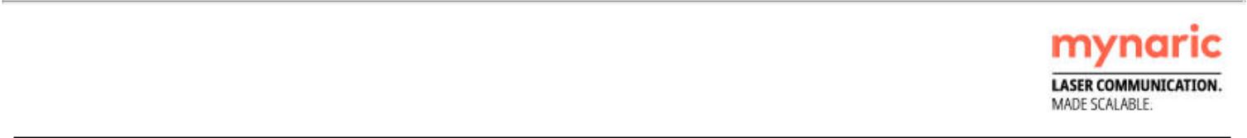
Other comprehensive income/loss for the period after tax | -500 | 367 | -43
Total comprehensive income/loss for the period | -45,873 | -19,403 | -9,939
Weighted average number of shares – basic and diluted | 4,250,134 | 3,349,403 | 2,831,427
Basic and diluted loss per share in EUR | -10.68 | -5.90 | -3.50
FY21 Shareholder Letter
Mynaric (NASDAQ: MYNA)(FRA: M0Y)
www.mynaric.com |  |  | Page 18/21

Analyst and Investor Day 2022

Mynaric will host an analyst and investor day today, April 28, 2022, at 12:00 p.m. Eastern Daylight Time (6:00 p.m. Central European Summer Time) with a management webcast presentation of our vision and strategy, our scale serial production capability, our success with new and existing customers and our full-year 2021 results and outlook. This will be followed by a question-and-answer session. A live audio webcast and replay of the webcast will be available in the Investor Relations section of mynaric.com

- Webcast registration (voice and slides): here

- Dial-in registration (voice only): here

The analyst and investor day webcast will include forward-looking information.

Investor Inquiries

Tom Dinges

VP of Investor Relations

+1 202 900 8332

tom.dinges@mynaric.com

About Mynaric

Mynaric (NASDAQ: MYNA)(FRA: M0Y) is leading the industrial revolution of laser communications by producing optical communications terminals for air, space and mobile applications. Laser communication networks provide connectivity from the sky, allowing for ultra-high data rates and secure, long-distance data transmission between moving objects for wireless terrestrial, mobility, airborne- and space-based applications. The company is headquartered in Munich, Germany, with additional locations in Los Angeles, California, and Washington, D.C.

For more information, visit mynaric.com.

FY21 Shareholder Letter
Mynaric (NASDAQ: MYNA)(FRA: M0Y)
www.mynaric.com | Page 19/21

Forward-looking statements

This shareholder letter includes forward-looking statements within the meaning of the Private Securities Litigation Reform Act of 1995, as amended. All statements other than statements of historical or current facts contained in this shareholder letter, including statements regarding our future results of operations and financial position, industry dynamics, business strategy and plans and our objectives for future operations, are forward-looking statements. These statements represent our opinions, expectations, assumptions, beliefs, intentions, estimates or strategies regarding the future, which may not be realized. Forward looking statements are often indicated by terms such as “anticipate,” “believe,” “could,” “estimate,” “expect,” “forecast,” “goal,” “intend,” “look forward to,” “may,” “plan,” “potential,” “predict,” “project,” “should,” “target” “will,” “would” and/or the negative of these terms or other similar expressions that are intended to identify forward-looking statements.

The forward-looking statements included in this shareholder letter are based largely on our current expectations and projections about future events and financial trends that we believe may affect our financial condition, results of operations, business strategy, short-term and long-term business operations and objectives, and financial needs. These forward-looking statements involve known and unknown risks, uncertainties and assumptions that are difficult to predict or are beyond our control, and actual results may differ materially from those expected or implied as forward looking statements. These risks, uncertainties and assumptions include, but are not limited to (i) the impact of any geopolitical tensions or the global COVID-19 pandemic on the global economy, our industry and markets as well as our business, (ii) risks related to our limited operating history, our history of significant losses and the execution of our business strategy,
- risks related to our ability to successfully manufacture and deploy our products and risks related to serial production of our products,
- risks related to our sales cycle which can be long and complicated, (v) risks related to our limited experience with order processing, our dependency on third-party suppliers and external procurement risks, (vi) risks related to defects or performance problems in our products, (vii) effects of competition and the development of the market for laser communication technology in general, (viii) risks related to our ability to manage future growth effectively and to obtain sufficient financing for the operations and ongoing growth of our business,

- risks relating to the uncertainty of the projected financial information, (x) risks related to our ability to adequately protect our intellectual property and proprietary rights and (xi) changes in regulatory requirements, governmental incentives and market developments. Moreover, new risks emerge from time to time. It is not possible for our management to predict all risks, nor can we assess the impact of all factors on our business or the extent to which any factor, or combination of factors, may cause actual results to differ from those contained in any forward-looking statements we may make. In light of these risks, uncertainties and assumptions, the forward-looking events and circumstances discussed in this shareholder letter may not occur and actual results could differ materially and adversely from those anticipated or implied in the forward-looking statements. We caution you therefore against relying on these forward-looking statements, and we qualify all of our forward-looking statements by these cautionary statements.

The forward-looking statements included in this shareholder letter are made only as of the date hereof. Although we believe that the expectations reflected in the forward-looking statements are reasonable, we cannot guarantee that the future results, levels of activity, performance or events and circumstances reflected in the forward-looking statements will be achieved or occur. Neither we nor any other person assumes responsibility for the accuracy and completeness of the forward-looking statements. Moreover, neither we nor any other person undertakes any obligation to update any forward-looking statement to

FY21 Shareholder Letter
Mynaric (NASDAQ: MYNA)(FRA: M0Y)
www.mynaric.com | Page 20/21

reflect events or circumstances after the date of this shareholder letter or otherwise. You should read this shareholder letter with the understanding that our actual future results, levels of activity, performance and events and circumstances may materially differ from what we expect.

Unless otherwise indicated, information contained in this shareholder letter concerning our industry, competitive position and the markets in which we operate is based on information from independent industry and research organizations, other third-party sources and management estimates. Management estimates are derived from publicly available information released by independent industry analysts and other third-party sources, as well as data from our internal research, and are based on assumptions made by us upon reviewing such data, and our experience in, and knowledge of, such industry and markets, which we believe to be reasonable. In addition, projections, assumptions and estimates of the future performance of the industry in which we operate and our future performance are necessarily subject to uncertainty and risk due to a variety of factors, including those described above. These and other factors could cause results to differ materially from those expressed in the estimates made by independent parties and by us. Industry publications, research, surveys and studies generally state that the information they contain has been obtained from sources believed to be reliable, but that the accuracy and completeness of such information is not guaranteed. Forecasts and other forward- looking information obtained from these sources are subject to the same qualifications and uncertainties as the other forward-looking statements in this shareholder letter.

This shareholder letter may include certain financial measures not presented in accordance with IFRS. Such financial measures are not measures of financial performance in accordance with IFRS and may exclude items that are significant in understanding and assessing our financial results. Therefore, these measures should not be considered in isolation or as an alternative to loss for the period or other measures of profitability, liquidity or performance under IFRS. You should be aware that our presentation of these measures may not be comparable to similarly titled measures used by other companies, which may be defined and calculated differently.

The trademarks included herein are the property of the owners thereof and are used for reference purposes only. Such use should not be construed as an endorsement of our products or services.

FY21 Shareholder Letter
Mynaric (NASDAQ: MYNA)(FRA: M0Y)
www.mynaric.com | Page 21/21

