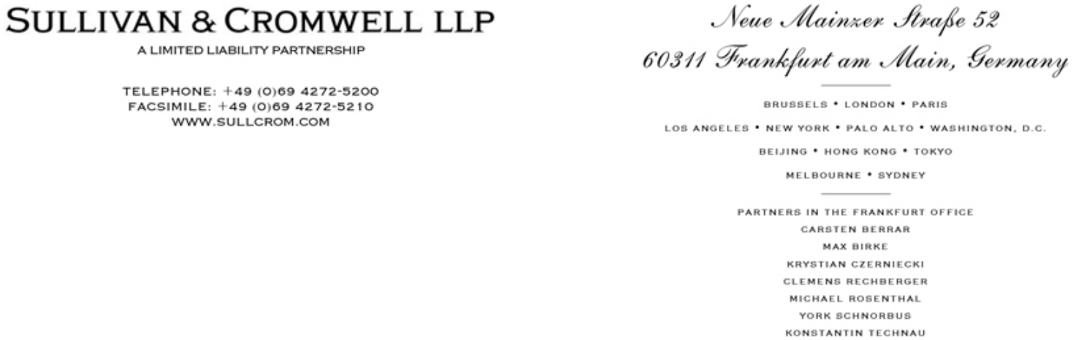

October 19, 2021

By Hand and EDGAR

United States Securities and Exchange Commission,

Division of Corporation Finance,

Office of Technology,

100 F Street, N.E.,

Washington, D.C. 20549.

Attention: Joseph Cascarano

Robert Littlepage

Alexandra Barone

Jan Woo

Re: Mynaric AG

Amendment No. 2 to Draft Registration Statement on Form F-1

Submitted September 24, 2021

CIK No. 0001850453

Ladies and Gentlemen:

Mynaric AG (the “Company”) has filed today, via EDGAR, this letter and Registration Statement on Form F-1 (the “Registration Statement”) with the staff of the Securities and Exchange Commission (the “Commission”). The Company previously submitted Amendment No. 2 to the Company’s draft registration statement on Form F-1 on a confidential basis with the Commission on September 24, 2021 (the “Draft Registration Statement”). In response to comment no. 1 in your letter dated October 7, 2021 relating to the Draft Registration Statement, the Company understands that the staff of the Commission is continuing to consider the supplemental information submitted by the Company regarding comment no. 10 of the staff’s comment letter of July 23, 2021.

Sullivan & Cromwell LLP is a registered limited liability partnership established under the laws of the State of New York.
The personal liability of our partners is limited to the extent provided in such laws. Additional information is available upon request or at www.sullcrom.com.

A list of partners’ names is available for inspection at the above address.

Securities and Exchange Commission | -2-
Division of Corporation Finance

Office of Technology

If you would like to discuss any aspect of the Registration Statement, please contact Krystian Czerniecki at +49-69-4272-5525 or by email (czernieckik@sullcrom.com). Please send written correspondence relating to this submission by email.

Very truly yours,

/s/ Krystian Czerniecki

Krystian Czerniecki

- Bulent Altan, Chief Executive Officer

Stefan Berndt-von Bülow, Chief Financial Officer Joachim Horwath, Chief Technology Officer (Mynaric AG)

Craig F. Arcella

Sasha Rosenthal-Larrea (Cravath, Swaine & Moore LLP)

