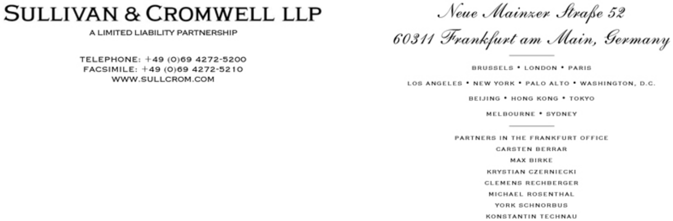

October 29, 2021

By Email and EDGAR

United States Securities and Exchange Commission,

Division of Corporation Finance,

Office of Technology,

100 F Street, N.E.,

Washington, D.C. 20549.

Attention: Joseph Cascarano

Robert Littlepage

Alexandra Barone

Jan Woo

Re: Mynaric AG

Registration Statement on Form F-1

Filed on October 19, 2021

File No. 333-260357

Ladies and Gentlemen:

Mynaric AG (the “Company”) has filed today, via EDGAR, this letter and Amendment No. 1 to the Registration Statement on Form F-1 (the “Amendment No. 1”) with the staff of the Securities and Exchange Commission. In response to comment no. 1 in your letter dated October 7, 2021 relating to the draft registration statement previously submitted on September 24, 2021, the Company has revised the disclosure in the Amendment No. 1 under the heading Summary Financial Data starting on page 17 and under the heading Management’s Discussion and Analysis of Financial Condition and Results of Operations starting on page 58 as well as the Company’s financial statements included therein.

Sullivan & Cromwell LLP is a registered limited liability partnership established under the laws of the State of New York.

The personal liability of our partners is limited to the extent provided in such laws. Additional information is available upon request or at www.sullcrom.com.

A list of partners’ names is available for inspection at the above address.

Securities and Exchange Commission | -2-
Division of Corporation Finance

Office of Technology

If you would like to discuss any aspect of the Amendment No. 1, please contact Krystian Czerniecki at +49-69-4272-5525 or by email (czernieckik@sullcrom.com). Please send written correspondence relating to this submission by email.

Very truly yours,

/s/ Krystian Czerniecki

Krystian Czerniecki

- Bulent Altan, Chief Executive Officer

Stefan Berndt-von Bülow, Chief Financial Officer Joachim Horwath, Chief Technology Officer (Mynaric AG)

Craig F. Arcella

Sasha Rosenthal-Larrea (Cravath, Swaine & Moore LLP)

